**Paweł Czubak**

**201520**

**Lingwistyka zadanie 6**

1. GRAMATYKA Z NAWIASAMI Z UŁAMKAMI

S ::= W ; Z

Z ::= W ; Z | $

W ::= PW'

W'::= OW | $

P ::= R | <W> *P ::= R | (W) () zastąpione <> bo mi się myli*

R ::= LR'

R'::= .L | $

L ::= CL'

L'::= L | $

C ::= 0 | 1 | 2 | 3 | 4 | 5 | 6 | 7 | 8 | 9

O ::= * | : | + | - | ^

**$ --> pusty znak**

L' = L | $

L' = CL' | $

L' = C{C}

L ::= CL'

L ::= C{C}

R'::= .L | $

R'::= [.C{C}] => wystąpi przecinek z cyfrą lub więcej cyfr LUB NIC

R ::= LR'

R ::= C{C}[.C{C}] => wystąpi cyfra a może wiele i może po nich . i cyfra lub wiele

W'::= OW | $

W'::= OPW' | $

W'::= {OP}

W ::= (R | <W>)W'

W'::= {O(R | <W>)}

P ::= R | <W>

W ::= (R | <W>){O(R | <W>)}

**S ::= W ; {W}**

**W ::= (C{C}[.C{C}] | <W>){O(C{C}[.C{C}] | <W>)}**

Nie da się zrobić wyrażenia regularnego gdyż nie pominie się tej rekurencji

Zad 6

S ::= W ; Z

Z ::= W ; Z | $

W ::= PW'

W'::= OW | $

P ::= R | <W> *P ::= R | (W) () zastąpione <> bo mi się myli*

R ::= LR'

R'::= .L | $

L ::= CL'

L'::= L | $

C ::= 0 | 1 | 2 | 3 | 4 | 5 | 6 | 7 | 8 | 9

O ::= * | : | + | - | ^

W ::= P | POW

L ::= C | CL

R ::= L | L.L

$ --> pusty znak

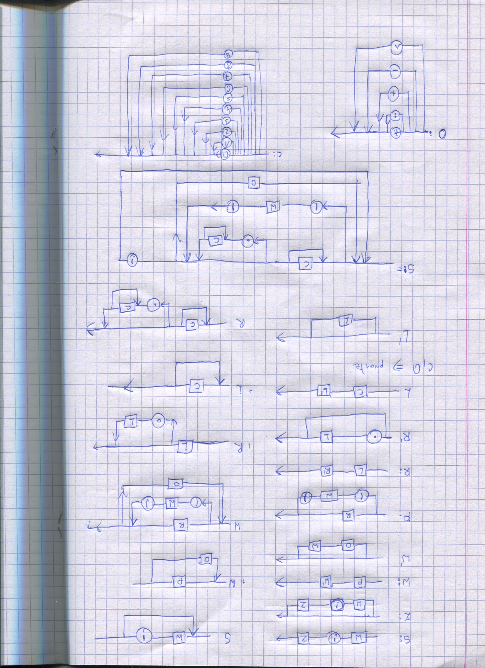

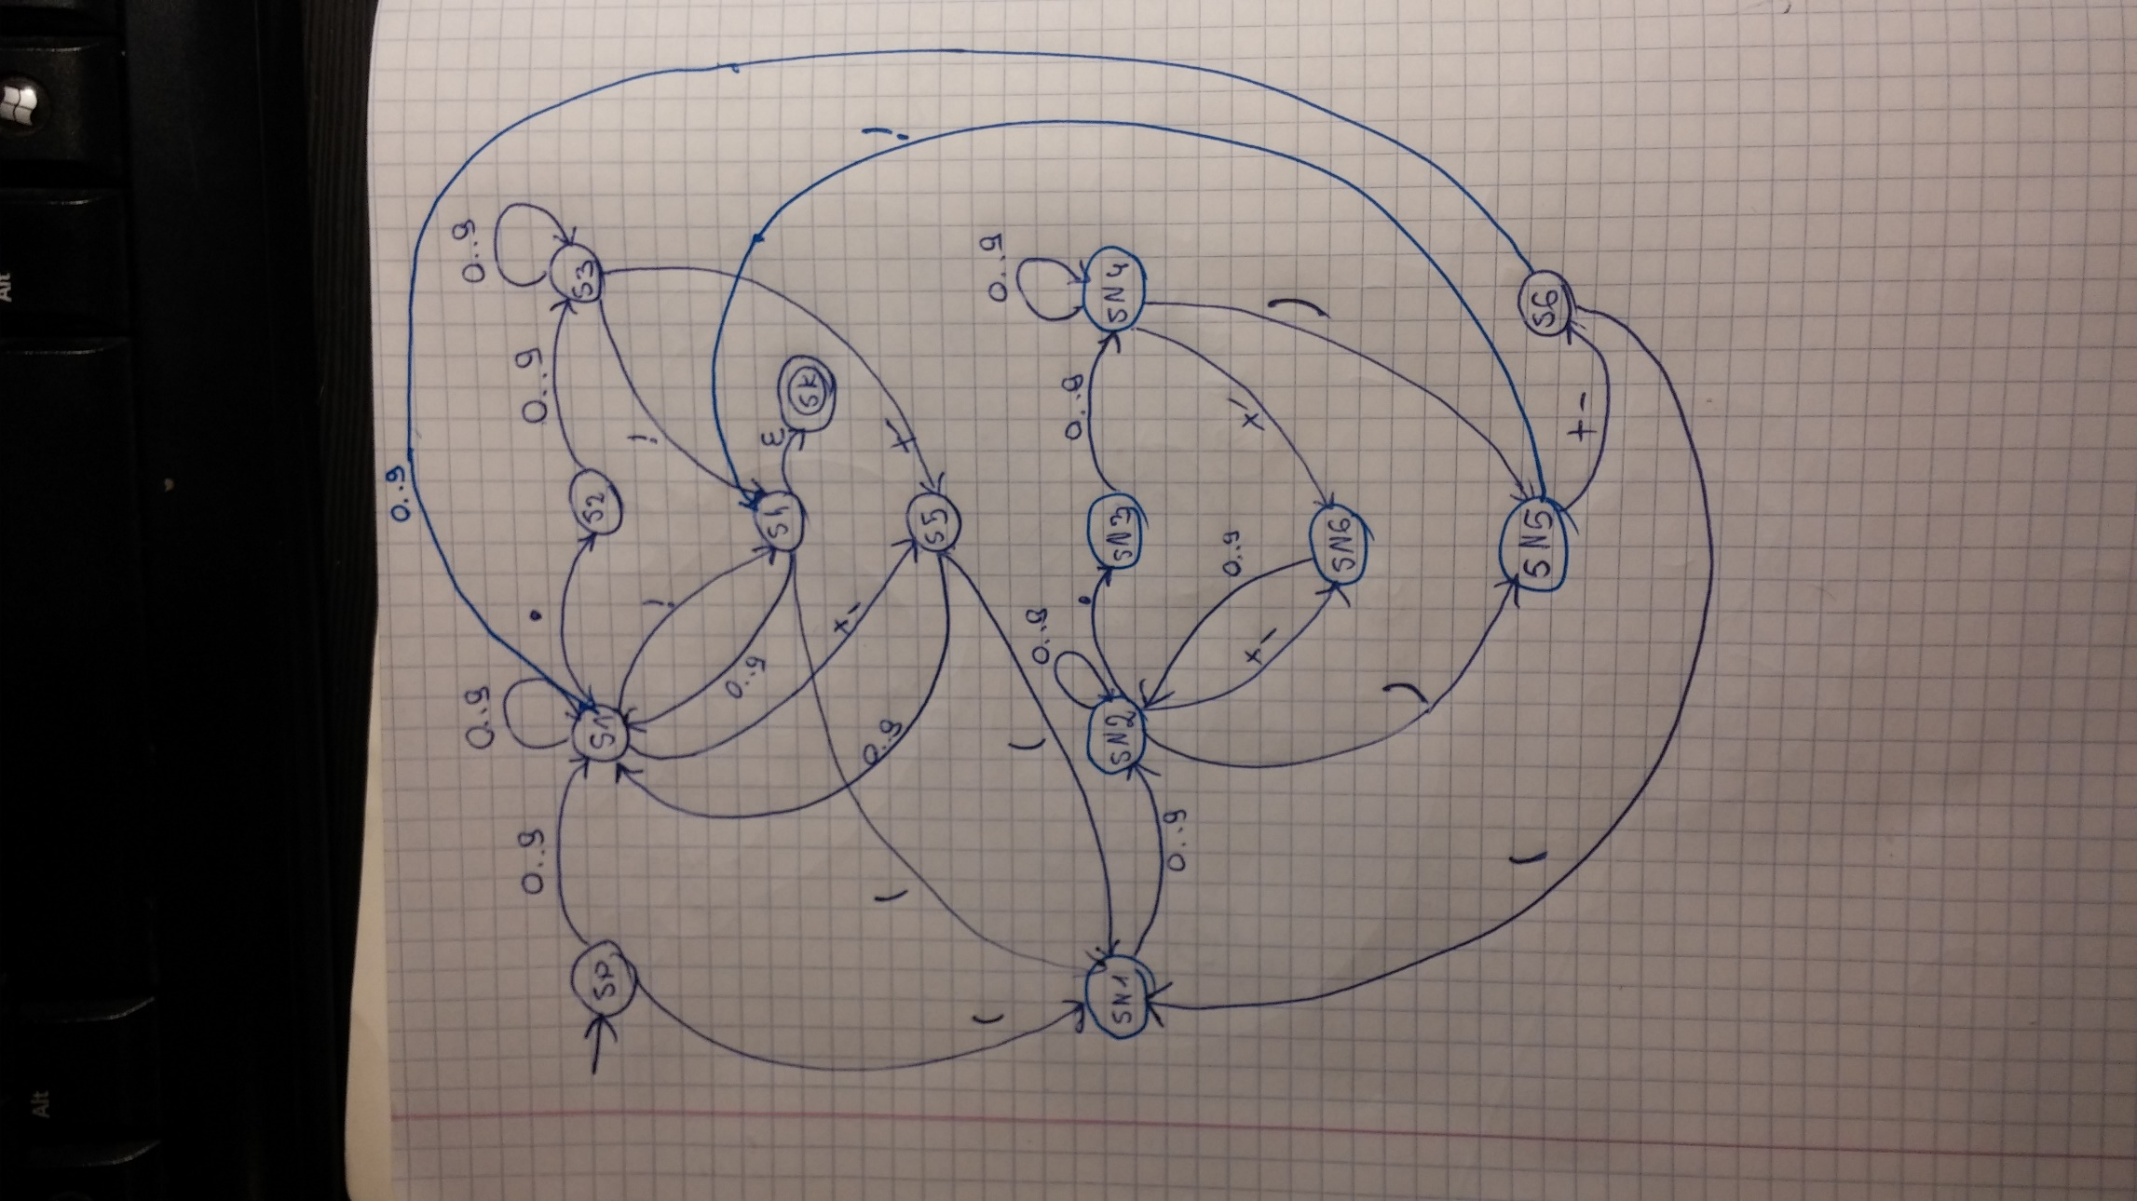

|  |  |  |  |  |  |  |  |
| --- | --- | --- | --- | --- | --- | --- | --- |
|  | 0..9 | . | ; | +-/* | ( | ) | $ - pusty |
| SP | S1 |  |  |  | SN1 |  |  |
| S1 | S1 | S2 | S4 | S5 |  |  |  |
| S2 | S3 |  |  |  |  |  |  |
| S3 | S3 |  | S4 | S5 |  |  |  |
| S4 | S1 |  |  |  | SN1 |  | SK |
| **S5 -> SP** | S1 |  |  |  | SN1 |  |  |
| **S6 -> SP** | S1 |  |  |  | SN1 |  |  |
| SN1 | SN2 |  |  |  |  |  |  |
| SN2 | SN2 | SN3 |  | SN6 |  | SN5 |  |
| SN3 | SN4 |  |  |  |  |  |  |
| SN4 | SN4 |  |  | SN6 |  | SN5 |  |
| SN5 |  |  | S4 | S6 |  |  |  |
| **SN6 -> SN1** | SN2 |  |  |  |  |  |  |
| SK |  |  |  |  |  |  |  |

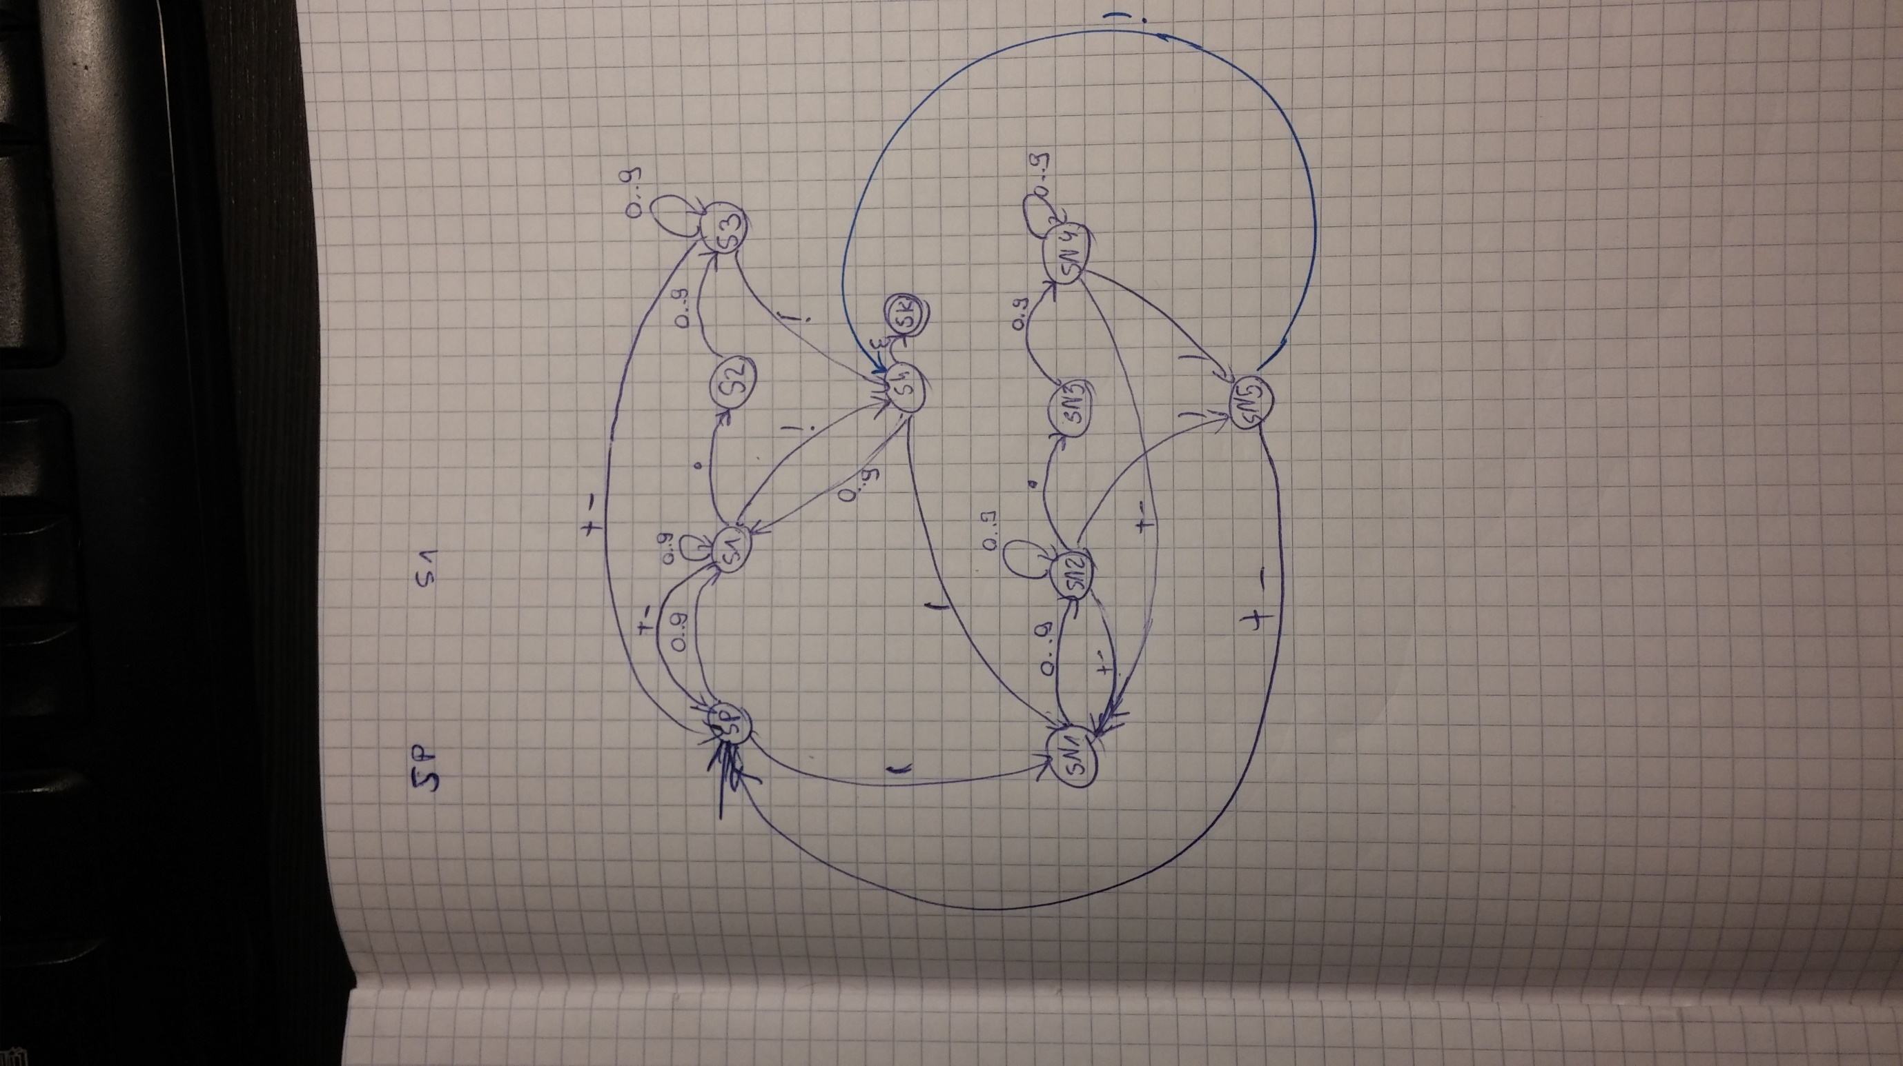

|  |  |  |  |  |  |  |  |
| --- | --- | --- | --- | --- | --- | --- | --- |
|  | 0..9 | . | ; | +-/* | ( | ) | $ - pusty |
| SP | S1 | --- | --- | --- | SN1 | --- | --- |
| S1 | S1 | S2 | S4 | SP | --- | --- | --- |
| S2 | S3 | --- | --- | --- | --- | --- | --- |
| S3 | S3 | --- | S4 | SP | --- | --- | --- |
| S4 | S1 | --- | --- | --- | SN1 | --- | SK |
| SN1 | SN2 | --- | --- | --- | --- | --- | --- |
| SN2 | SN2 | SN3 | --- | SN1 | --- | SN5 | --- |
| SN3 | SN4 | --- | --- | --- | --- | --- | --- |
| SN4 | SN4 | --- | --- | SN1 | --- | SN5 | --- |
| SN5 | --- | --- | S4 | SP | --- | --- | --- |
| SK | --- | --- | --- | --- | --- | --- | --- |